Changes document for MS Decom activities

Project: z_2t65_cslv3ssc

System : xFE

CD: XXXXXXXXX

Transport request: XXXXXXXXXX

—---------------------------------------------------------------------------------------------------------------------------------

1. Adding a new button as Export to my Drive in SSC view.

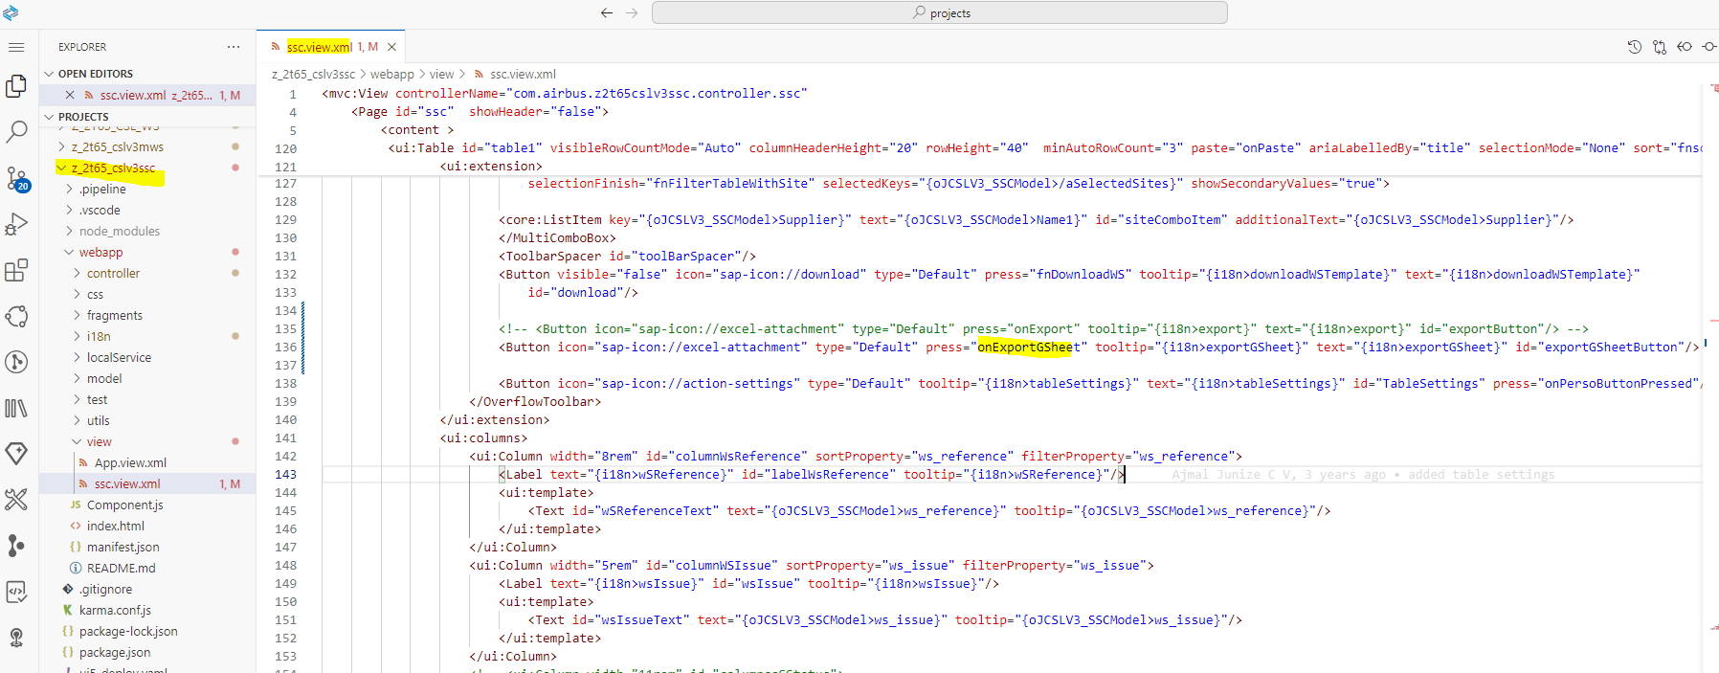

1. Below logic to fetch the data based on the filters from odata service and export it to google sheet.

